CEE 691-001 Midterm Exam Take-Home Part 2/28/08
Shibo Wang
Note: All the following work is done by my own effort without any collaboration or discussion with other individuals.

Problem 5.9
Solution:
(a) Original Function
Assume n iterations are needed to attain an absolute error of 0.05ºC, then
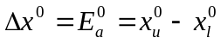
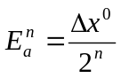
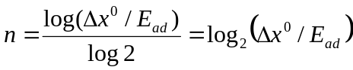
Since E_{ad}=0.05 ºC, 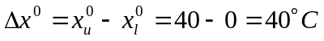
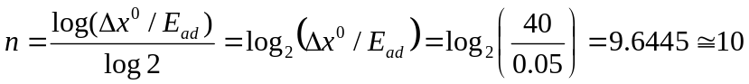
Therefore, 10 iterations are required to achieve the required absolute error.

(b) M-file is shown below:
function [root,Ea,iter] = bisect1(OSF,xl,xu,Ead)
% bisect:root location zeroes
%[root,ea,iter] = bisect(func,xl,xu,es):
% uses bisection method to find the root of func
% input:
% func = name of function
% xl,xu = lower and upper guesses
% Ea = desired absolute error
% output:
% root = real root
% Ead = desired absolute error
% iter = number of iterations
% OSF=Saturated Dissolved Oxygen Concentration
% T=absolute temperature
f=@(OSF,T)-log(OSF)-139.34411+(157570.1/(T+273.15))-(66423980/(T+273.15)^2)+(12438000000/(T+273.15)^3)-(862194900000/(T+273.15)^4);
test = f(OSF,xl) * f(OSF,xu);
if test >0, error( 'no sign difference'), end
iter = 0; xr = xl;
while (1)
xrold = xr;
xr = (xl + xu)/2;
iter = iter +1;
Ea = (xu-xl)/(2^iter);
test = f(OSF,xl)* f(OSF,xr);
if test <0
xu = xr;
elseif test >0
xl = xr;
else
root=xr;
end
if Ea <= Ead break, end
end
root = xr;

Run the Matlab:
>> bisect1(8,0,40,0.05)
ans =
26.2109
>> bisect1(10,0,40,0.05)
ans =
14.8828
>> bisect1(12,0,40,0.05)
ans =
6.9922

Therefore, for saturated dissolved oxygen concentration of 8,10,12 mg/L respectively, the temperature of the water body should be 26.2109, 14.8828, and 6.9922 ºC.

Problem 12.7
Solution:
The simultaneous nonlinear equations:
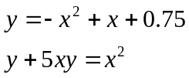
Therefore,
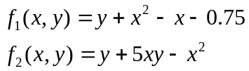
Initial guesses of x=y=1.2
Newton-Raphson method is applied: which has the following basic equation
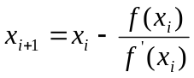
First compute the partial derivatives and evaluate them at the initial guesses of x and y:
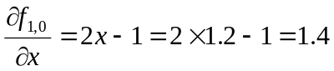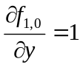
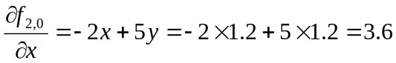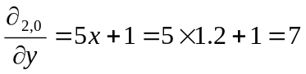
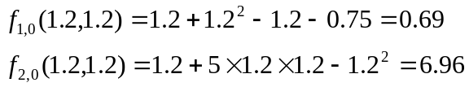
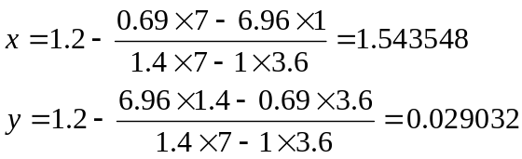
Percent Relative Error: 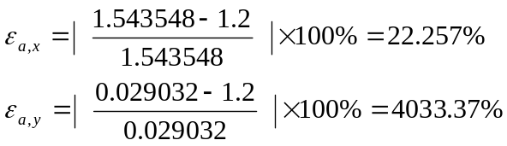

For the second iteration:
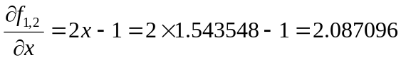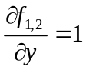
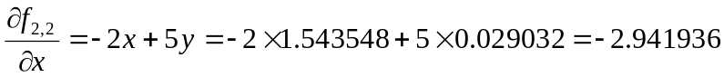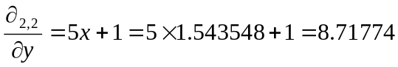
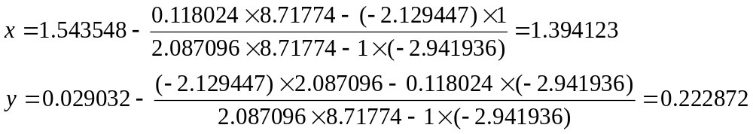
Percent Relative Error: 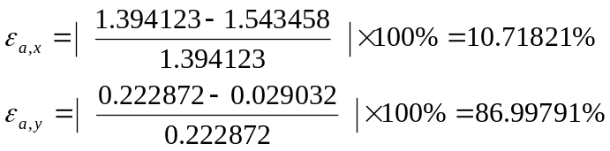

For the third iteration:
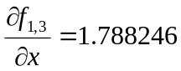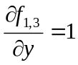
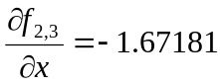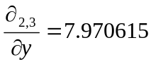
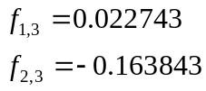
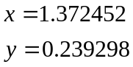
Percent Relative Error: 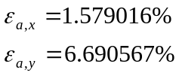

For the fourth iteration:
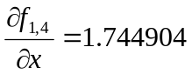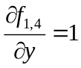
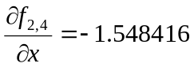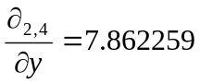
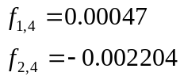
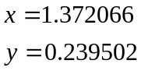
Percent Relative Error: 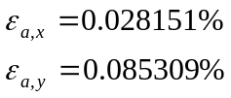

For the fifth iteration:
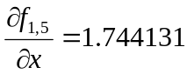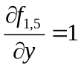
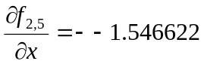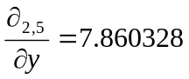
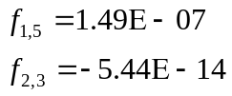
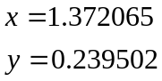
Percent Relative Error: 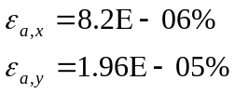
Therefore, according to Newton Raphson Method, the roots of the simultaneous equations are
* The original data is pasted in the attachment.

Original Data:
Problem 12.7
iteration | x | y | F’_{1,x} | F’_{1,y} | F’_{2,x} | F’_{2,y} | f₁ | f₂ | Ea,x(%) | Ea,y(%)
1 | 1.2 | 1.2 | 1.4 | 1 | 3.6 | 7 | 0.69 | 6.96 | 22.25703 | 4033.37
2 | 1.543548 | 0.029032 | 2.087096 | 1 | -2.941936 | 8.71774 | 0.118024 | -2.129447 | 10.71821 | 86.99791
3 | 1.394123 | 0.223287 | 1.788246 | 1 | -1.67181 | 7.970615 | 0.022743 | -0.163843 | 1.579016 | 6.690567
4 | 1.372452 | 0.239298 | 1.744904 | 1 | -1.548416 | 7.862259 | 0.00047 | -0.002204 | 0.028151 | 0.085309
5 | 1.372066 | 0.239502 | 1.744131 | 1 | -1.546622 | 7.860328 | 1.49E-07 | -5.44E-07 | 8.2E-06 | 1.96E-05
6 | 1.372065 | 0.239502

